MUZAMMIL KAUSAR

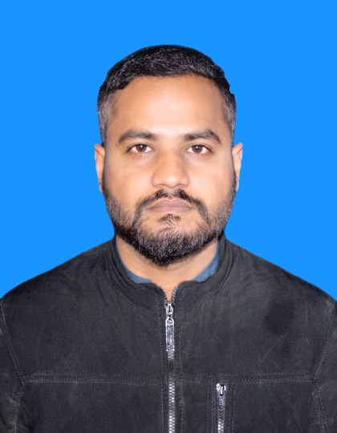

OBJECTIVES:

Seeking a highly challenging environment in a growing organization

having culture of teamwork to become a part of organizational growth.

EDUCATION :
- Matric ( Govt Kohinoor Boys High School Rawalpindi, 2011 )

ADDITIONAL COURSE:
- 6 Months Auto Mechanic EFI Course
- 3 Years Apprenticeship In SUZUKI Taxila Motors
- Bronze Qualified From SUZUKI Taxila Motors
- Silver Qualified From SUZUKI Racecourse Motors
- Gold Qualified From SUZUKI Racecourse Motors

SKILLS :
- Ability To Diagnose And Resolve Faults
- Can Perform Multiple Tasks Simultaneously
- Hard Working And Punctual

EXPERIENCE :

10 Years Of Experience In Automobile Field

PERSONAL INFORMATION:

- Name : Muzammill Kausar
- Father Name : Kausar Mehmood
- Date of Birth : 01-07-1994
- CNIC : 37201-6600566-5
- Marital Status : Single
- Domicile : Punjab ( Rawalpindi )
- Religion : Islam
- Contact # : 0348-5316021
- Gmail Address : zamil0348@gmail.com
- Address : House No# 26 Street NO#3A Mohallah
Naseerabad Kohinoor Mills Peshawar Road Rawalpindi Cantt.

